**EXPERIMENT 3**

**RELATIONAL MODEL FOR A COLLEGE DATABASE**

**Aim:** Draw a relational model for a college database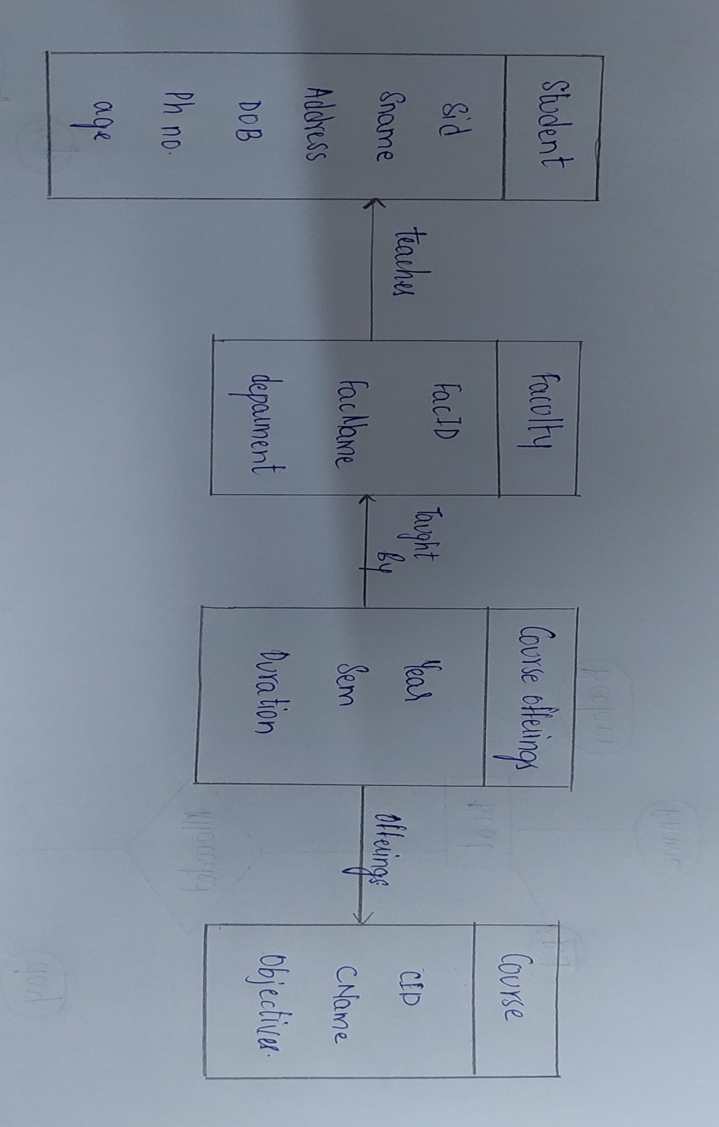

offerings

Taught By

teaches

FacID  
FacName   
Deparment

**Faculty**

Year  
sem  
duration

**Course offerings**

Cid  
CName  
objectives

**Course**

Sid  
Sname  
Address  
DOB  
Phno  
age

**Course**